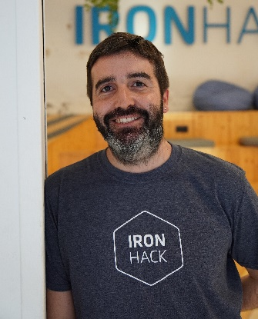**Sergi** Alvarez Guasch

600 853 521

[https://www.linkedin.com/in/sergi-alvarez-guasch](https://www.linkedin.com/in/sergi-alvarez-guasch/?locale=en_US)

<sergiguasch83@gmail.com>

08027 Barcelona

**MAIN ROLES**

**Data Analyst** - Python, SQL, Tableau, Machine Learning.

**GIS Technician** - QGIS, ArcGIS, PyQGIS, Microstation

**EXPERIENCE**

**2020 – 2022** Solucions Geogràfiques. Barcelona **GIS technician**

* GIS analysis (ArcGIS, QGIS, Microstation)
* Data base management and technical reports

**2017 – 2020** GEOMEDI – *Surveying Digital Studio.* Barcelona **Surveying technician**

* CAD projects (Microstation)
* Management, data analysis and technical reports
* Surveys and stakeout topographics.

**2015 – 2016** Zirkonzahn Worldwide. Italia **CAD/CAM technician**

* CAD/CAM projects
* Management, order processing and offers
* Representation at events and exhibitions

**2011 – 2012** C.R.E.A.F. Barcelona **GIS & Remote Sensing technician**

**2009 – 2010** Observatori Socioambiental de Menorca. Maó **GIS technician**

* Preparing the Land Cover Map of Catalonia (MCSC)
* Preparing the land cover map of Menorca
* GIS analysis, geometric, radiometric and photogrammetry corrections

**EDUCATION**

2022 **Data Analytics Bootcamp**. Python, SQL, Tableau, Machine Learning. IronHack

2020 **Professional** **Master in GIS. Specialization in Geospatial Analysis** UdG - UNIGIS.

2020 Programming **Python-PyQGIS**. MappingGIS

2013 Oriented Object Programming **JAVA 2SE & C++**. Centre d’Informàtica Professional - CIPSA

2011 **Master in Remote Sensing and Geographical Information Systems**. UAB

2010 **Bachelor's Degree in Geography**. UAB

**LANGUAGES, TECH SKILLS & PROJECTS**

**English IELTS *National Tertiary Education Consortium (New Zealand, 2015)***

***New Zealand Institute of Studies (New Zealand, 2014)***

Spanish Native or bilingual proficiency

Catalan C1 Native or bilingual proficiency

Italian A2

**QGIS; ArcGIS; MiraMon; Tableau; Python (PyQGIS); MySQL, PostgreSQL (PostGis); CARTO; Mapbox; Microsation**

[**https://github.com/SergiGuasch/Projects.git**](https://github.com/SergiGuasch/Projects.git)

*Driving license B - own vehicle*

December 26, 1983